iPad iMovie Project
Overview!

Using iMovie, you will create a 1-2 minute video based on the “style” of the AP Today in History news we usually begin class with. Your video will be based on your birth date and it will include both life (personal) and world events. Upon the completion of your project, you will email a copy of the video to your parents and to yourself. Also, you will put a copy of the completed video on your Google Drive so you will be able to present it to the class. This is important since iPads are being returned soon. General requirements are as follows:
- Complete the research page of the project and obtain teacher approval before continuing.
- Fill in the movie script based on your research page and begin making your movie using iMovie.
Using iMovie
Follow your script while completing the following:
- Start your video with the Today in History intro video clip that I emailed you.
- Include The Day in History transition slide after the intro.
- Your birth date info will be the first event.
- You will include at least THREE other life events besides your birthday. They don’t have to be on your birthday, but only state the year of the event if it does not fall on your birthday.
- You will include at least FIVE world events based on your birthday which have occurred throughout time. One should be a culturally based event such as music or art.
- It should end with the culture related event based on your birthday. (Sports, music, movies, books, authors – anything with a cultural relevance.)
- Provide pictures/videos with all events!
- Email finished video to you and your parents.
- Place a copy in your google drive.
Due Date: ___________
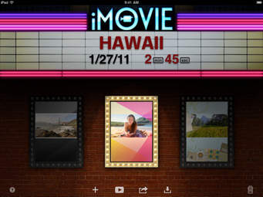
We will learn to use iMovie together. I will provide examples as we help each other master the application on your iPad.

