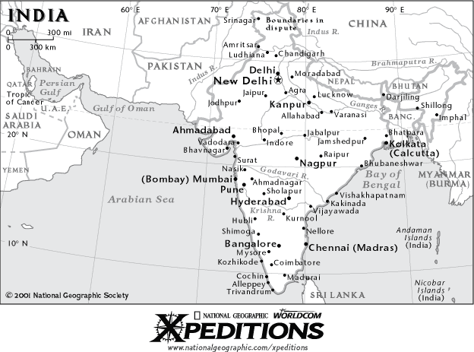

*Indian Ocean*

Be able to label the following areas on the map:

Afghanistan

Arabian Sea

Bangladesh

Bay Of Bengal

Bhutan

China

Himalayas

India

Indian Ocean

Iran

Myanmar (Burma)

Nepal

Pakistan

Sri Lanka

INDIA

Name:______________________ Date: __________________ Test Date:_____

**Directions**: Study The Areas Listed below: