Africa Research Project – Keynote Project Name __________________ Due Date _______
Instructions: You are to use Keynote (iPad App) or PowerPoint to create a slideshow over an African Country. You will create one slide for each of the following topics. There will be at least 11 slides but you may add more if it helps in your presentation. The underlined words below should be included in the title for each slide. Picture(s) should be included on each slide .You will use suggested websites below and google to research your country. You must keep track of all websites used and cite them on the last page using EasyBib or Citation Machine. You will share your slideshow with at least two classmates. This intended to be an in-class project.
- Introduction of Country Slide
  - Name, Country, Picture
- (Brief) History Slide
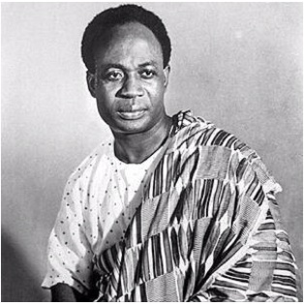
  - Give a short summary of major events in the country’s history. (Timelines are great for this information.)
- Demographics & A Famous Person Slide (Their George Washington!)
  - Population, population growth rate, language, Ethnic Groups
  - Include their most famous historical person!
- Government Slide
  - Government type, capital city, Ruler, Voting(suffrage)
- Climate/Geography Slide
  - Land Area, Temperature, Landforms/Terrain (mountains, rivers, deserts)
- Economics Slide
  - Imports, exports, currency, exchange rate
Kwame Nkrumah
- Landmarks/Famous Places Slide (Highlight at least two places.)
  - Important Places to Visit
- Healthcare Slide
  - Life expectancy(total, male female), obesity rate
- Culture Slide
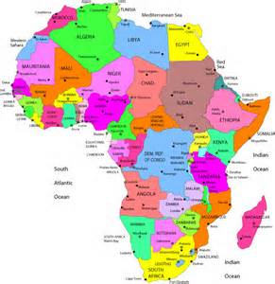
  - Cuisine, literature/performing arts/painter/inventor
- A Current Event or Issue Slide
  - Current Event or Issue facing country
- Work Cited/Bibliography Slide
  - MLA style reference for any information/ pictures.
  - EasyBib http://www.easybib.com/
  - Citation Machine http://www.citationmachine.net/
  - Keep an electronic list of websites used for citing
Recommended Web Sites:
Library Research Tools http://wrmslibrary.weebly.com/research-tools.html
World Book Student http://classic.worldbookonline.com/student/home
Encyclopedia Britannica http://school.eb.com/levels/middle
Global Issues in Context http://find.galegroup.com/gic/start.do?prodId=GIC&userGroupName=j227909042
National Geographic Kids http://natgeo.galegroup.com/natgeo/archive?u=j227909042&prodId=NGMK
CIA Fact Book https://www.cia.gov/library/publications/the-world-factbook/index.html
CULTURE GRAMS http://online.culturegrams.com/index.php (Username: wrms Password: wildcats)
Africa Historical Eras http://web.cocc.edu/cagatucci/classes/hum211/timelines/htimelinetoc.htm
Landmarks http://famouswonders.com/africa/
Famous Africans http://www.biographyonline.net/politicians/african/changed-world.html
Current Events http://www.cnn.com/WORLD/africa/archive/ http://www.africanevents.com/
And Internet Searches (Keep Record of URL’S of everything!)

